**DBMS ASSIGNMENT 10**

**CLASS: TE B**

**ROLL NO: 322008**

**Problem Statement:** Design and Develop MongoDB Queries using CRUD operations. (Use CRUD operations, SAVE method, logical operators)

**Screenshots:**

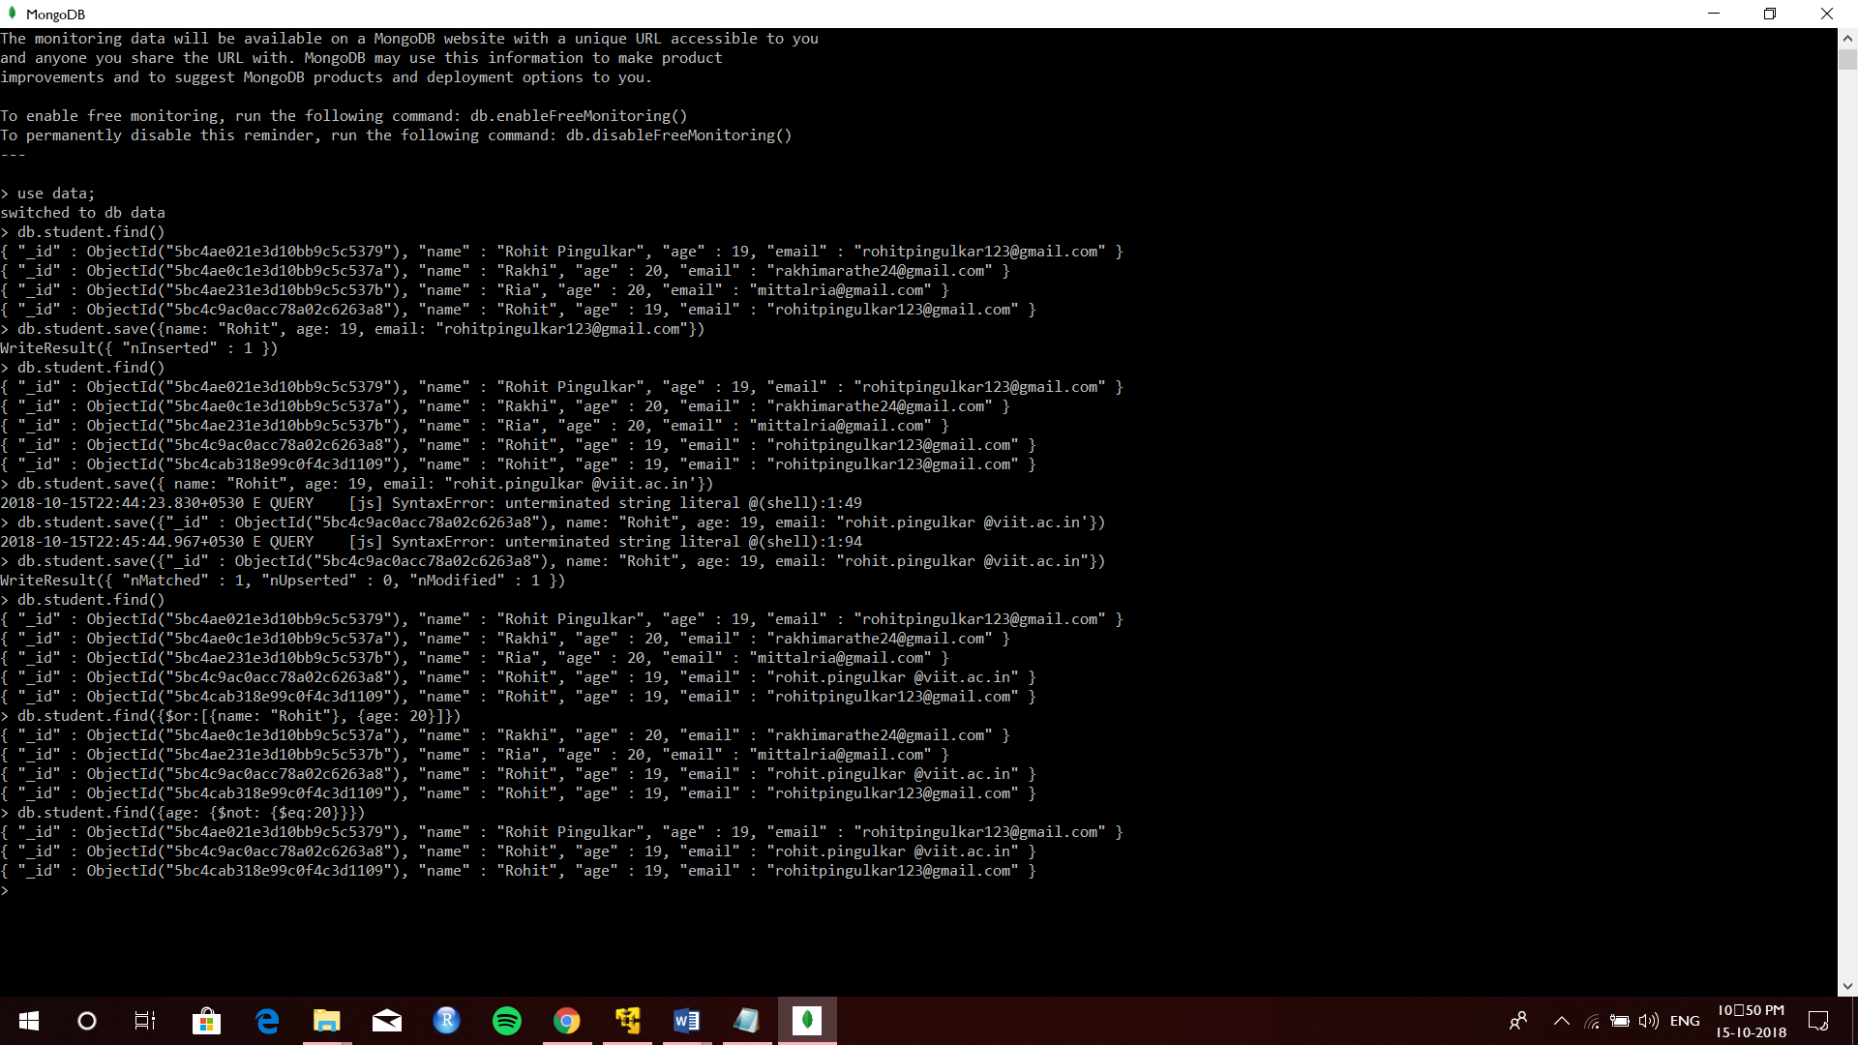

**Queries:**

Db.student.find();

Db.student.save({“name” : “Rohit”, age : 19, “email” = “rohitpingulkar123@gmail.com”});

Db.student.save({“name” : “Rohit”, age : 19, “email” = “rohit.pingulkar@viit.ac.in”});

Db.student.find({$or{name : “Rohit”}, {age : 20}});

Db.student.find({age : {$not : {$eq 20}}});

**Conclusion:** MongoDB CRUD and save operation were successfully implemented.